Kosher Chocolates Sales Analytics
Business Intelligence & Sales Analytics Portfolio Project
Project Overview
The Kosher Chocolates Sales Analytics project is an end-to-end Business Intelligence reporting solution developed in Microsoft Power BI. The project transforms raw shipment and sales transactions into a structured analytical model and interactive dashboard for monitoring sales performance, profitability, shipment activity, product performance, geographic performance, and sales representative performance at large.
Business Problem
Kosher Chocolates required a centralized reporting solution to help management monitor sales performance, track month-over-month movement, profitability analysis, identify high-performing products and categories, compare geographical regions, monitor sales representative performance, analyses shipment and box volumes, and support data-driven decisions.
- Monitor overall sales performance
- Track month-over-month sales movement
- Analyze profitability and profit margins
- Identify high-performing products and categories
- Compare sales performance across geographies
- Monitor sales representative performance
- Analyze shipment and box volumes
- Identify underperformance and growth opportunities
Dataset
The spreadsheet source file contains Shipment Data, Dimension Data, and a Calendar Table. The current dataset contains 6,113 shipment records, 22 products, 25 sales representatives, 6 geographies, and a reporting period from February 2023 to February 2024.
- Total Sales: $34.04M
- Total Boxes: 2.08M
- Total Costs: $13.52M
- Total Profit: $20.52M
- Profit Margin: 60.3%
Data Model
The Power BI model uses a star-schema approach with shipment transactions at the center and supporting dimensions for products, people, locations, and dates. Supporting measure and selector tables are also used for interactive reporting.
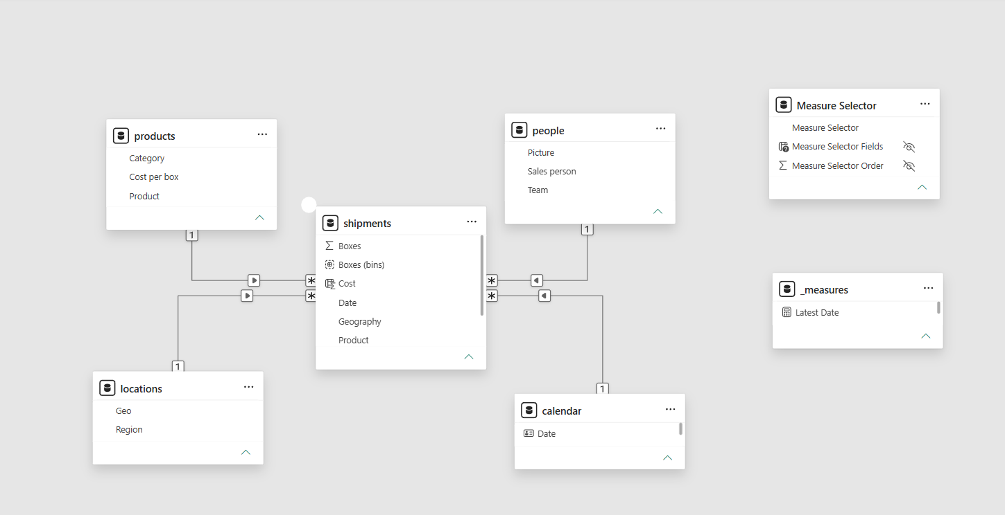
Business Intelligence Development Approach
Source Data → Data Transformation → Data Modelling → DAX Measures → KPI Development → Interactive Reporting → Business Insights
- Data transformation and preparation
- Dimensional/star-schema modelling
- DAX measure development
- KPI and profitability analysis
- Interactive dashboard and slicer development
- Business insight generation and recommendations
Dashboard Features
- Executive KPI overview
- Sales trend analysis
- Product performance analysis
- Sales representative performance
- Shipment distribution analysis
- Geographic filtering
- Category filtering
- Metric selection
- Conditional formatting and performance indicators
Key KPIs
- Total Sales: $34.04M
- Total Boxes: 2.08M
- Total Shipments: 6.11K
- Total Costs: $13.52M
- Total Profit: $20.52M
- Profit Margin: 60.3%
- Latest MoM Sales Change: -10.8%
Key Business Insights
Category Performance
Bars generated approximately $17.08M in sales, followed by Bites at approximately $10.15M and Other at approximately $6.82M. Bars are therefore the largest revenue contributor.
Product Profitability
The dashboard highlights material differences in product profitability. Peanut Butter Cubes is a strong example of a high-margin product, while several lower-margin products warrant closer profitability monitoring.
Geographic Performance
Sales are relatively balanced across the six countries. New Zealand recorded the highest total sales in the current dataset, while the UK recorded the lowest.
Sales Trends
Monthly sales show several peaks and troughs. The latest month records a 10.8% month-over-month decline, creating a clear opportunity for management to investigate the drivers by product, geography, and sales representative.
Sales Representative Performance
The sales representative table provides a management view of individual sales, profit, profit percentage, LBS percentage, and performance status indicators.
Business Impact
The dashboard creates a centralized Business Intelligence reporting layer that converts transactional sales data into a decision-support environment. It reduces reliance on manual spreadsheet reporting, improves KPI visibility, supports faster filtering and drill-down analysis, and strengthens product, geographic, and sales performance monitoring.
• Faster access to management information
• Centralized KPI monitoring
• Improved visibility into product profitability
• Better geographic performance monitoring
• Greater visibility into sales representative performance
• Support for inventory, sales, and promotional planning

Recommendations
- Investigate the latest 10.8% MoM sales decline by product, geography, and sales representative.
- Protect and prioritize high-margin products while reviewing lower-margin product economics.
- Use geographic performance to develop targeted commercial strategies.
- Use sales performance data to guide coaching, recognition, and incentives.
- Expand the BI model with customer, inventory, promotions, targets, returns, and forecasting data.

Tools & Skills
- Microsoft Power BI
- Power Query
- DAX (Data Analysis Expressions)
- Dimensional Data Modelling
- Star Schema
- Interactive Data Visualization
- Business Intelligence Reporting
- Excel
- Data Cleaning & Transformation
- KPI Development
- Executive Reporting
- Data Storytelling

Conclusion

The Kosher Chocolates Sales Analytics project demonstrates how Business Intelligence, dimensional modelling, DAX, and interactive visualization can transform transactional sales data into a practical management reporting solution. It demonstrates capability across the BI lifecycle, from data preparation and modelling through to executive reporting, insight generation, and ultimately business recommendations.

